**How to Install GitLab Runner on Ubuntu 20.04 LTS**

## Step #1: Add the Official GitLab Repository

First add the official GitLab Repository using below command, to check latest Gitlab Repository visit the [official GitLab Runner page](https://docs.gitlab.com/runner/install/linux-repository.html)

curl -L "https://packages.gitlab.com/install/repositories/runner/gitlab-runner/script.deb.sh" | sudo bash

## Step #2: Install GitLab Runner on Ubuntu

Run below command to install latest GitLab Runner on Ubuntu 20.04 LTS

sudo apt-get install gitlab-runner

use below commands to install specific version of GitLab Runner on Ubuntu.

apt-cache madison gitlab-runner

sudo apt-get install gitlab-runner=10.0.0

Command to check GitLab Runner version

sudo gitlab-runner -version

**Output:**

Version: 13.4.1

Git revision: e95f89a0

Git branch: 13-4-stable

GO version: go1.13.8

Built: 2020-09-25T20:03:43+0000

OS/Arch: linux/amd64

To check status if GitLab Runner service is running or not

sudo gitlab-runner status

**Output:**

Runtime platform arch=amd64 os=linux pid=29368 revision=e95f89a0 version=13.4.1

gitlab-runner: Service is running!

Commands to Start, Stop and Restart GitLab Runner

sudo gitlab-runner start

sudo gitlab-runner stop

sudo gitlab-runner restart

## Step #3: Grant sudo Permission to GitLab Runner User

After install GitLab Runner you will see gitlab-runner user in **/home** directory

cd /home

ls

**Output:**

gitlab-runner ubuntu

To grant sudo permission to gitlab-runner user, ope the visudo file

sudo visudo

Add the gitlab-runner user in sudoers group and set **NOPASSWD**as shown below

gitlab-runner ALL=(ALL:ALL) ALL

gitlab-runner ALL=(ALL) NOPASSWD: ALL

**Output:**

# Host alias specification

# User alias specification

# Cmnd alias specification

# User privilege specification

root ALL=(ALL:ALL) ALL

**gitlab-runner ALL=(ALL:ALL) ALL**

# Members of the admin group may gain root privileges

%admin ALL=(ALL) ALL

# Allow members of group sudo to execute any command

%sudo ALL=(ALL:ALL) ALL

# See sudoers(5) for more information on "#include" directives:

#includedir /etc/sudoers.d

**gitlab-runner ALL=(ALL) NOPASSWD: ALL**

## Step #4: Register GitLab Runner to GitLab on Ubuntu

**1.** First login to GitLab Server with Username and Password.



**2.** Click on your project and select **Settings**

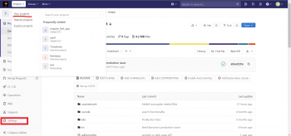

**3.** Navigate to Settings and click on CI/CD inside this click on Expand of **Runners** section

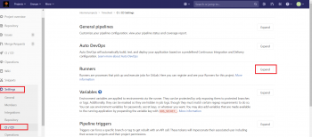

**4.** Copy GitLab server URL and Registration Token as shown below.

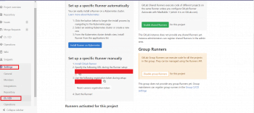

**5.** Paste GitLab Server URL and Token in registration command as below

$ gitlab-runner register --name project-name-runner --url https://**gitlab.fosstechnix.com** --registration-token  **Uc7yzxTMzsXhXJx3zgM**

**OR**

sudo gitlab-runner register

**OR**

if you want to register gitlab-runner with docker executor then use below command

sudo gitlab-runner register \

--non-interactive \

--url "GITLAB_SERVER_URL" \

--registration-token "REGISTRATION_TOKEN" \

--description "docker-runner" \

--executor "docker" \

--docker-image ubuntu:latest

6. Copy above command. Login to GitLab runner server through SSH and paste & run copied command on command line.

Follow the default options until which agent you need to register and then select agent as shown below

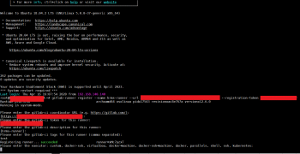

**7.** Once you registered Runner for project then you will get runner as below,

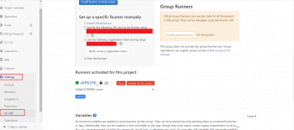

Successfully, We have performed GitLab Runner Registration.

**Error: This job is stuck because the project doesn’t have any runners online assigned to it. Go to Runners page.**

**Solution:**

You have added tags while registering GitLab Runner however you have not added tags for your Job.

Follow below steps to add tags.

1. Navigate to **Settings** and click on **CI/CD**inside this click on Expand of **Runners** section

2. **Go to Runners** and check on**Indicates whether this runner can pick jobs without tags Box**

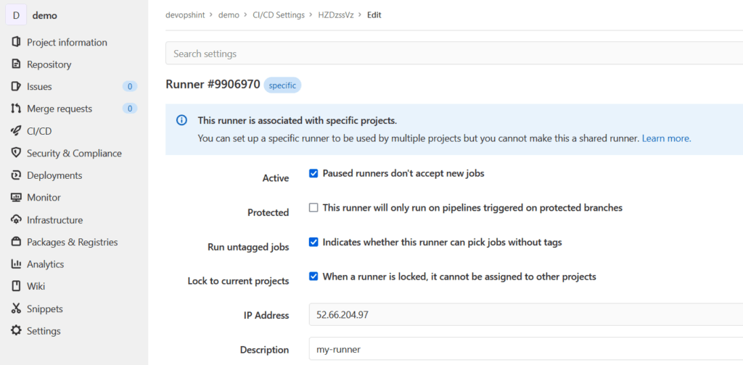

## Uninstall GitLab Runner from Ubuntu

First remove the gitlab-runner using apt

sudo apt purge --autoremove -y gitlab-runner

Remove the gitlab-runner apt key

sudo apt-key del 51312F3F

Remove gitlab-runner apt repository

sudo rm -rf /etc/apt/sources.list.d/runner_gitlab-runner.list

Remove the gitlab-runner user and directory

sudo deluser --remove-home gitlab-runner

Remove gitlab-runner installation directory

sudo rm -rf /etc/gitlab-runner